Password Capturing Using Wireshark
Wireshark is a network packet analyzer that can capture and inspect the data travelling through a network. Depending on the protocol being used, the captured traffic may contain information such as usernames, passwords, email IDs, and other details.
For example, when protocols like HTTP, FTP, or Telnet are used without proper encryption, sensitive information may be visible in the captured packets. Wireshark is mainly used for network monitoring and troubleshooting, but it can also help us understand how information is transmitted over a network.
Here, we will see how login information can be identified from captured HTTP traffic in an authorized testing environment.
Step 1:
First, open Wireshark on your Windows system or Linux virtual machine. Select the network interface you want to monitor, such as Wi-Fi, and start capturing the packets.

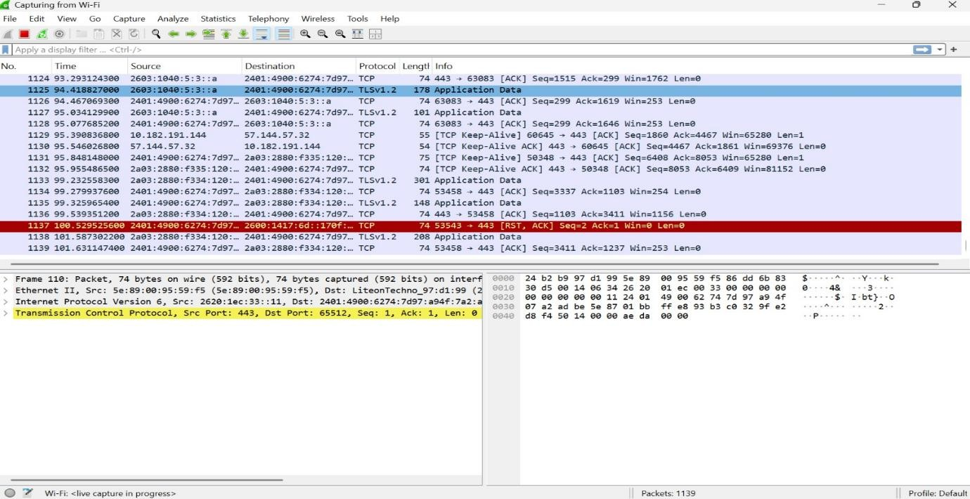

Step 2:
After starting the packet capture, open the required test website in a browser. Enter the username and password in the login form and submit the details.

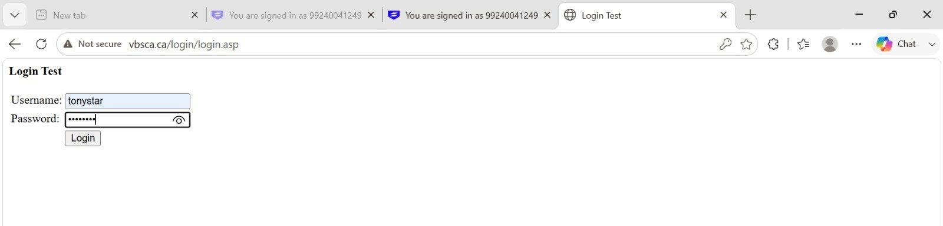

Step 3:
After completing the login, return to Wireshark and look through the packets that were captured during the login process.
Since Wireshark may have captured a large number of packets, we need to apply suitable filters to find the packets related to the login request.
Step 4:
First, we will look for HTTP packets. In the display filter bar of Wireshark, enter:
http
This will show the HTTP packets that were captured during the session.

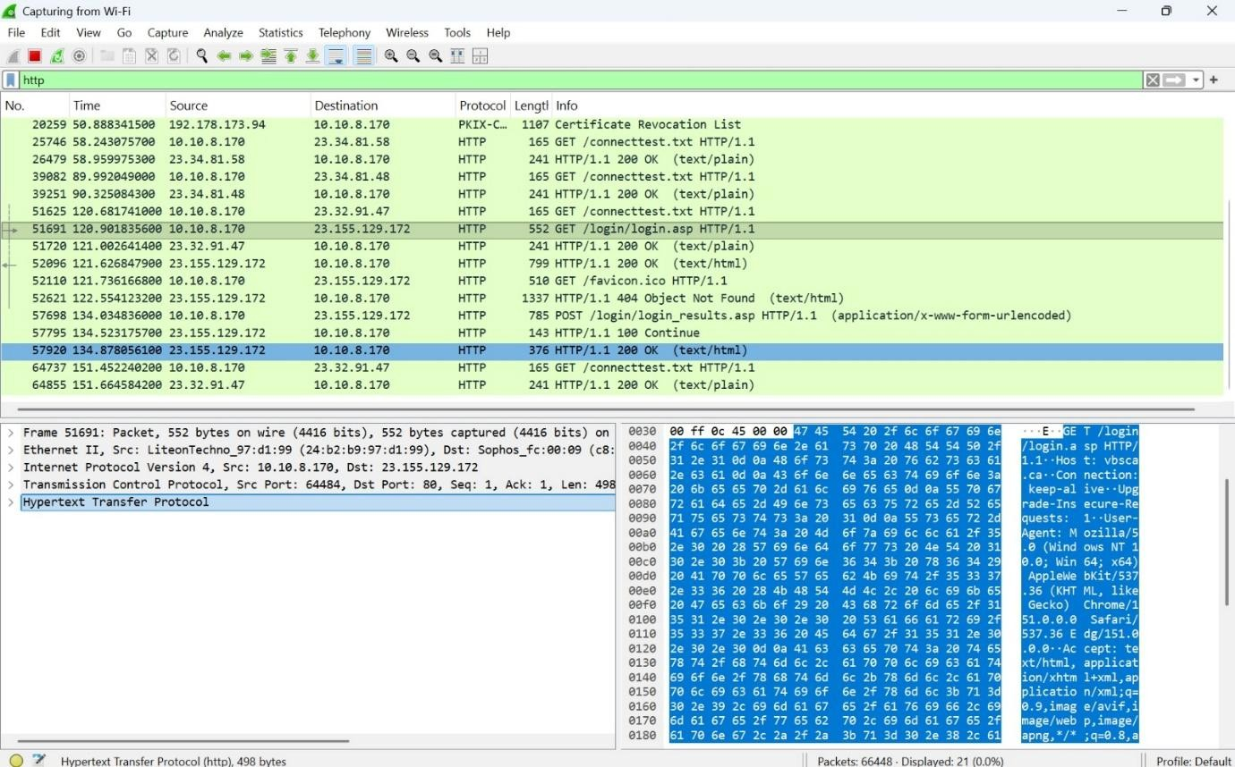

Step 5:
Now we need to find the request that contains the information submitted through the login form.
Normally, web forms use two common HTTP request methods:
- GET
- POST
Step 6: GET Method
First, we can check the GET requests by applying the following filter:
http.request.method == "GET"
After applying the filter, we may see packets related to the login page being requested using the GET method.
However, the actual login details may not be present in these packets. If we cannot find the required form data, we can check the POST requests.

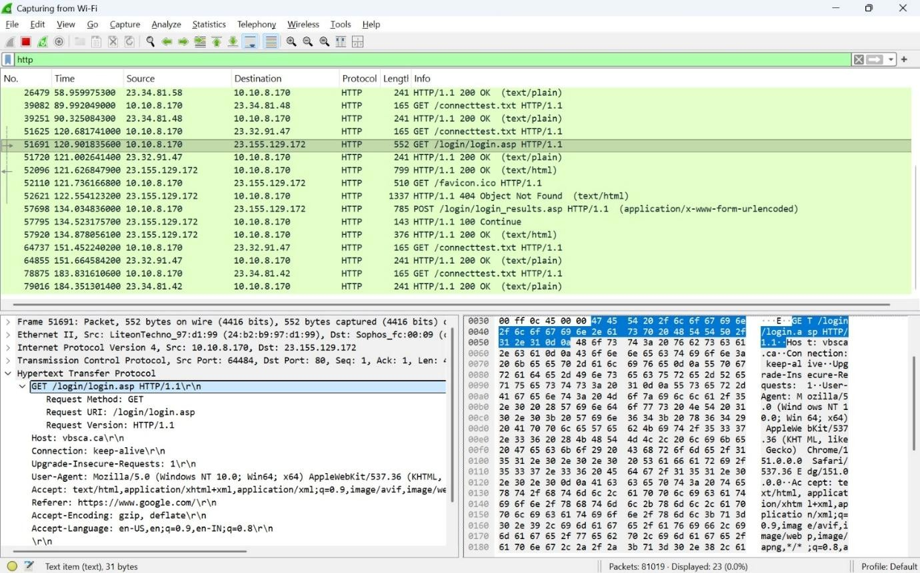 there is no form data submitted with a GET request.
Step 7: POST Method
To find POST requests, apply the following filter:
http.request.method == "POST"
Now, Wireshark will display the packets that use the POST method. Select the packet related to the login request and inspect its details.
Inside the packet details, look for the HTML Form URL Encoded section. If the connection is using unencrypted HTTP, the submitted form fields may be visible here.
For example:
Form item: "uname" = "tonystar"
Form item: "pass" = "12345678"
These values are the same credentials that were entered into the test login form.

